Annwyl Julia Donaldson…
Llythyr oddi wrth yr awdur plant poblogaidd yn cyrraedd un o ysgolion Sir Ddinbych

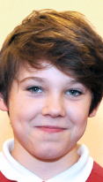
Pan benderfynodd Callum Kelly, 11 mlwydd oed, disgybl yn Ysgol Frongoch, Dinbych, ysgrifennu at un o'i hoff awduron, ychydig oedd y disgwyl ganddo cael ymateb. Felly dychmygwch ei syndod a’i lawenydd pur pan ddaeth llythyr yn ddiweddar, wedi'i gyfeirio’n bersonol ato, oddiwrth awdur 'The Gruffalo', Julia Donaldson, a anfonwyd at ei ysgol.

Mae Julia Donaldson MBE, y llenor Saesneg, dramodydd a pherfformiwr, ac Awdur Llawryfog Plant 2011-2013, yn fwyaf adnabyddus am ei storïau sy’n odli sydd mor boblogaidd gyda plant. Yn arbennig o boblogaidd yw’r rhai a ddarluniwyd gan Axel Scheffler, sy'n cynnwys 'Room on the Broom' a 'Stick Man'.
Callum Kelly

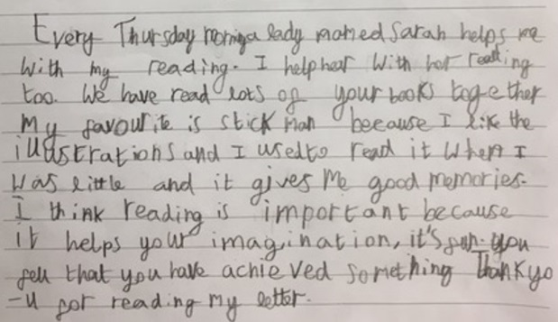
Yn ei chyfarchiad personol, siaradodd Miss Donaldson am ei balchder mewn ‘dysg’ a’r ffaith fod Callum yn mwynhau darllen ei llyfrau, yn enwedig 'Stick Man'. Ysgrifennodd hi, "Rwy'n mwynhau ysgrifennu llyfrau i blant ac mae'n dda gwybod eich bod yn mwynhau eu darllen. Aeth yn ei blaen, "Mae lluniadau Alex Scheffler yw wych ac yn llawn o liwiau llachar hyfryd, felly mae llawer i'n helpu i ddod â'r straeon yn fyw".
Dyfyniad o lythyr Callum

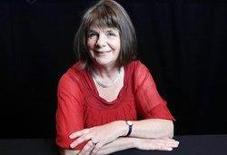
Dros y cwpl o fisoedd sydd wedi mynd heibio, mae Callum wedi bod yn cymryd rhan yn y fenter Mentora Darllen Sir Ddinbych; cynllun sy’n croesawu gwirfoddolwyr o bob cefndir i helpu disgyblion mewn ysgolion i wella eu sgiliau darllen a darganfod yr hud o ddarllen mewn ffordd hwyliog, creadigol ac ysbrydoledig. "Pan fyddwch yn darllen gyda rhywun, gallwch blymio i mewn i stori a chwerthin gyda'n gilydd, meddai Callum, "a rhannu bydoedd newydd, sy'n dal eich dychymyg". "Mae darllen yn beth mor bwysig i'w wneud a dwi mor lwcus i gael pobl i fy helpu i archwilio byd o eiriau".
Julia Donaldson MBE

Ac wedi troi ei sylw y tymor hwn i ddarllen "Planet Earth II", nid yw'n anodd i weithio allan at pwy fydd Callum yn ysgrifennu at nesaf!

Os hoffech chi gael gwybod mwy am Fenter Mentora Darllen Sir Ddinbych, cysylltwch ag Adran Addysg a Gwasanaethau Plant Sir Ddinbych ar 01824 708064.

Dear Julia Donaldson…
A letter from popular children’s author arrives in Denbighshire School

When Callum Kelly, aged 11 and a pupil at Ysgol Frongoch, Denbigh, decided to write to one of his favourite authors, little did he expect her to reply. So imagine his amazement and sheer delight when a letter, personally addressed to him, from ‘The Gruffalo’ author, Julia Donaldson, was delivered to his school recently.

Julia Donaldson MBE, English writer, playwright and performer, and the 2011–2013 Children's Laureate, is best known for her popular rhyming stories for children, especially those illustrated by Axel Scheffler, which include ‘Room on the Broom’ and ‘Stick Man’.
Callum Kelly

In her personal greeting, Miss Donaldson spoke of her delight in learning that Callum enjoyed reading her books, especially ‘Stick Man’. She wrote, “I really enjoy writing books for children and it’s good to know that you enjoy reading them. She continued, “Alex Scheffler’s drawings are wonderful and full of lovely bright colours, so there’s lots to help us bring the stories to life”.
Excerpt from Callum’s letter

Over the past couple of months, Callum has been taking part in Denbighshire’s Reading Mentoring initiative; a scheme welcoming volunteers from all walks of life to help pupils in schools improve their reading skills and discover the magic of reading in a fun, creative and inspiring way. “When you read with someone, you can dive into a story and laugh together, said Callum, “sharing new worlds, which capture your imagination”. “Reading is such an important thing to do and I’m so lucky to have people to help me to explore the world of words”.
Julia Donaldson MBE

And having turned his attention this term to reading “Planet Earth II”, it’s not hard to work out who Callum will be writing to next!

If you would like to find out more about Denbighshire’s Reading Mentoring initiative, please contact Denbighshire Education and Children’s Services on 01824 708064.

