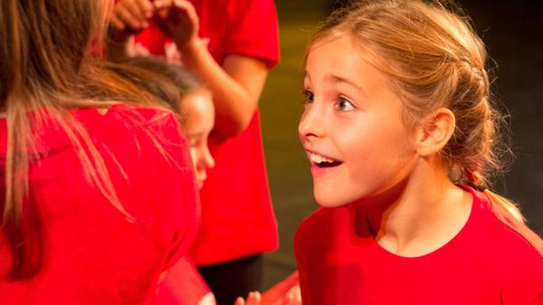
YSGOLION SIR DDINBYCH MEWN PERFFORMIADAU ARDDANGOS DISGLAIR YNG NGŴYLGYFOETH SIR DDINBYCH.2015

Dros y ddwy nos Wener diwethaf, fel rhan o Ŵylgyfoeth.2015 - Cael Eich Ysbrydoli!... a drefnwyd gan Wasanaethau Addysg Sir Ddinbych, llwyfanwyd sioeau trawiadol o ddrama, dawns, canu a dawnsio stryd wedi eu perfformio gan blant a phobl ifanc o ysgolion o bob rhan o Sir Ddinbych. ‘Roedd rhain yn berfformiadau syfrdanol wrth fodd cynulleidfaoedd orlawn o rieni a gwesteion a lanwodd Pafiliwn Llangollen a Theatr Pafiliwn Y Rhyl. Yn ystod y ddau ‘Perfformiadau Arddangos’, cafwyd sioe oleuadau symudol a sistemau sain arbennig, a’r cyfan wedi ei goreograffu a’i ddysgu mewn llai na 20 awr gan blant o Ysgolion Cynradd, Uwchradd ac Arbennig y Sir. Er mwyn paratoi'r plant, comisiynwyd gweithdai arbennig a dosbarthiadau meistr wedi’u rhoi ar eu cyfer yn Ninbych a'r Rhyl gan berfformwyr West End ac ymarferwyr o Lundain o Ysgol Llwyfan Haf mwyaf blaenllaw y DU, dan arweiniad eu cyfarwyddwr creadigol Mark Puddle, brodor o Ogledd Cymru, un o impressarios theatrig ifanc mwyaf blaenllaw'r wlad. Y canlyniad oedd dau berfformiad anhygoel awr o hyd, yn llawn o ganeuon adnabyddus o sioeau poblogaidd a ffilm, yn amrywio o 'Beauty and the Beast', 'Charlie and the Chocolate Factory’, 'Shrek', 'Frozen', 'The Lion King 'a' Mary Poppins'. Roedd y cynulleidfaoedd oedd wedi pacio i mewn i’r ddau theatr wedi eu swyno ac yn curo dwylo yn ystod ac yn dilyn pob cân gan eu bod wedi rhyfeddu at y fath ansawdd uchel o berfformiadau gan y plant heb iddynt oedi yn ystod y sioeau 60 munud, a redodd yn ddi-dor ac yn llyfn o gan i gan. ‘Roedd pob plentyn a gymerodd rhan yn 'seren' yn eu rhinwedd eu hunain ac ‘roeddent i gyd yn disgleirio’n llachar. Cymerwyd pob gofal i sicrhau bod yr holl berfformwyr wedi’u paratoi’n llawn i fwynhau'r profiad o ymddangos ar lwyfan enfawr, llawer ohonynt am y tro cyntaf erioed. ‘Roedd y bloeddio uchel a’r cymeradwyaeth ar ôl pob can yn dangos faint ‘roedd y cynulleidfaoedd yn gwerthfawrogi'r adloniant – ‘roedd y cyfan yn fwy rhyfeddol o ystyried yr amser paratoi byr ac ystod oedran y plant, rhai ohonynt mor ifanc â phump. I gloi, pwy all byth ag anghofio’r olygfa o weld pob un o'r plant ar y llwyfan yn eu crysau-T gŵylgyfoeth.2015 coch yn canu eu rhif terfynol o sioe 'The Lion King' neu y dawnsio i 'Uptown Funk'. Sut allech chi byth guro’r fath ddiweddglo?!!

DENBIGHSHIRE SCHOOLS IN DAZZLING ENRICHFEST.2015 SHOWCASE PERFORMANCES

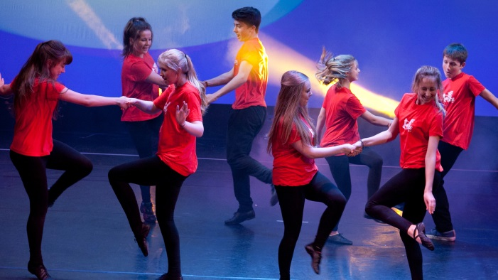
For the last two Friday evenings, as part of Denbighshire Education Service’s Enrichfest.2015 - Get Inspired!, stunning shows of drama, dance, singing and street dance were performed by children and young people from schools from across Denbighshire. These breath-taking performances thrilled sell-out audiences of parents and guests who filled Llangollen Pavilion and Rhyl Pavilion Theatre. Both Showcase Performances, complete with state of the art moving lights and sound systems, had been choreographed and learned in less than 20 hours by children from county Primary, Secondary and Special schools. In order to prepare the children, specially commissioned workshops and masterclasses had been given in Denbigh and Rhyl by West End performers and practitioners from London-based ‘West End Stage’, the UK’s leading Summer Stage School, who were led by creative director Mark Puddle, a native of North Wales and one of the country’s leading young theatrical impressarios. The result was two amazing hour long performances, full of well-known songs from popular shows and film, ranging from ‘Beauty and the Beast’, ‘Charlie and the Chocolate Factory’, ‘Shrek’, ‘Frozen’, ‘The Lion King’ and ‘Mary Poppins’. The packed audiences were in raptures and cheered and clapped each song as they marvelled at the quality of the children’s performances in non-stop, 60 minute shows, which ran seamlessly and smoothly from number to number, without a pause. Each and every child who took part was a ‘star’ in their own right and they all shone brightly. Every care had been taken to ensure that each performer had been fully prepared to enjoy the experience of appearing on a huge stage, many for the first time ever. The loud cheering after each number showed how much the audiences appreciated the entertainment - it was all the more remarkable given the short preparation time and the age range of the children, some of whom were as young as five. Finally, who could ever forget the spectacle of seeing all of the children on stage in their red enrichfest.2015 T-shirts, singing their final number from ‘The Lion King’ or dancing to ‘Uptown Funk’. How could you ever match that for a finale?!!

