Matt Parker: Stand-Up and Be Counted
Probably the BEST STAND-UP COMEDY in Denbighshire
Wednesday 3 February 2016 at 7pm
Denbigh High School, Denbigh

If you’re looking for a fun night out in Denbighshire, with one of the country’s best stand-up comedians, then we can assure you, you’ve landed on the right planet. "Stand-up mathematician" Matt Parker is appearing at Denbigh High School, Denbigh, on Wednesday 3 February, 7 pm, courtesy of Denbighshire Pathways+. His stand-up comedy show is suitable for all, motivating and exponentially funny.

Matt Parker is as good as it gets in the World of Stand-Up Comedy. A personable guy who says that the US sitcom “The Big Bang Theory” is “disturbingly true to life”; he is infectiously enthusiastic about science – but particularly maths – a subject that he is helping to yank from the airless classroom of your memory and revive it for the digital age.

He knows what he’s talking about when it comes to maths and comedy. Possibly the only person to hold the prestigious title of London Mathematical Society Popular Lecturer, while simultaneously having a sold-out comedy show at the Edinburgh Festival Fringe, Matt is always keen to mix his two passions of mathematics and stand-up.

Now the Public Engagement in Mathematics Fellow at Queen Mary, University of London, a few years ago, he took a stand-up comedy course and discovered a growing market for geeky laughs. He joined the London circuit and in 2011 co-founded the Festival of the Spoken Nerd ("physics porn for the sci-curious", as one reviewer put it). He's also part of the insanely popular Numberphile YouTube channel, also launched in 2011, which has a million subscribers and almost 100 million video views. Matt's most popular clip is a 13-minute exploration of the number zero that has been viewed 1.3 million times.

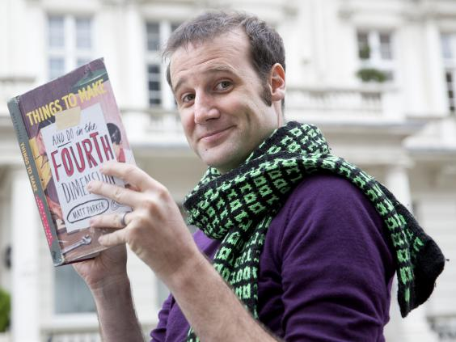
Matt is a regular on BBC Radio 4′s “Infinite Monkey Cage” with Robin Ince and Brian Cox; he frequently pops up in various TV and radio news and light entertainment shows to talk about maths (BBC News, Sky News, Channel 4′s Sunday Brunch) and he occasionally writes for The Guardian. He is a presenter on Discovery’s “You Have Been Warned” and QuestTV’s “World’s Top Five” along with recent guest appearances in Channel 4′s
Matt Parker, author of Things To Make And Do in the Fourth Dimension
(Teri Pengilley/The Independent)
“How to Find Love Online” talking stats and CBBC’s “How to Be Epic at Everything” solving Rubik’s Cubes. Matt will also appear in the next series of Dick and Dom’s Absolute Genius.

As part of a two day visit to North East Wales (3-4 February), Matt will also be hosting “Think Maths” Schools’ Sessions for Denbighshire Secondary Schools on Thursday 4 February 2016 and inspiring a new generation of mathematicians.

