Ryan Hall aka Dougy74 Design – Inspired by the Force…

When Daniel Bailes, a pupil at Blessed Edward Jones RC High School, Rhyl, was named as Denbighshire’s Young Artist of the Year 2015, little did he know then that as part of his prize, he and his schoolmates would be hosting a workshop with Ryan Hall, aka Dougy74 Design (pictured left), one of the UK’s most talented young Freelance Designers, Illustrators, Creators and Exhibitionist of Paper Toys.

From an early age, Ryan has had a love for creating, especially with paper but it wasn't until university that he found his true calling as a Paper Toy Maker. Influenced by his childhood love of pop-culture and Masters of the Universe, Doctor Who and Teenage Mutant Ninja Turtles, Ryan has seen his work on exhibition, in print and on-line media over the last 4 years:

Since leaving Glyndŵr University in 2010, Ryan has exhibited his work all over the world from the USA and Europe, alongside various other leading artists. He has hosted his own shows in London and Cardiff and has artwork permanently on display at the Star Wars Museum Rancho Obi-Wan in CA, USA.

Many of Ryan’s influences in his art come from ‘pop culture’ and science fiction and are, in his own words, “just the plain all out wacky”. He has also illustrated book covers for Doctor Who, featured in publications such as the new Star Wars book, “Inspired By The Force” by Steve Sansweet, sci-fi journals and Art books.
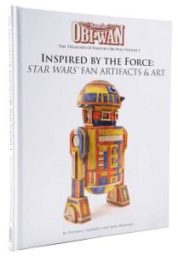
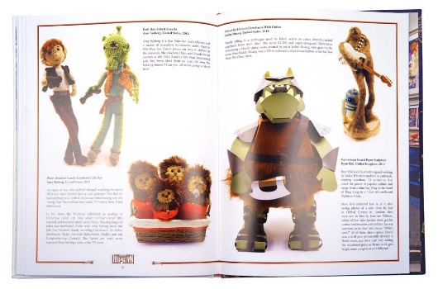

Ryan is looking forward to facilitating the schools’ workshop in January 2016 with students from Blessed Edward Jones RC High School and Rhyl High School and teaching them the art of paper toy making. “I enjoy doing workshops with children and young people. Seeing their imagination come to life and watching them enjoy making something is just amazing to see”.

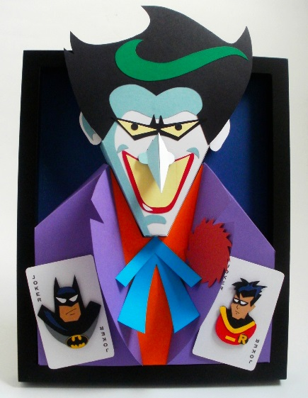
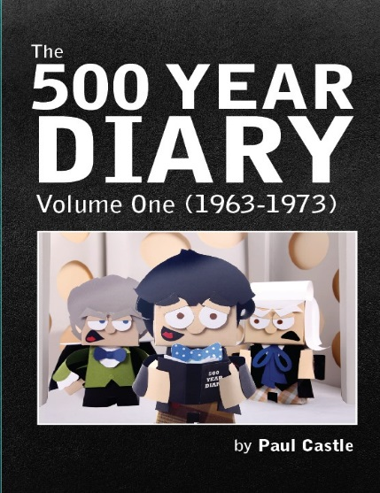
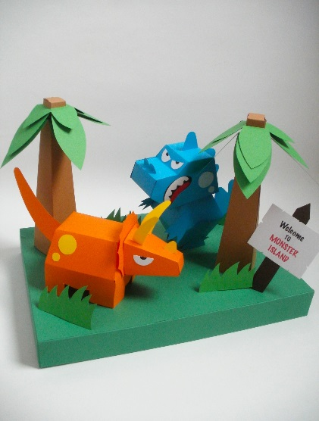

This engaging workshop will enable Rhyl school children to take their creativity, enjoyment and skills to the next level. Who knows, we could be looking at the next Ryan Hall!...

If you'd like to get in touch or know more about the awesome Ryan Hall, here’s his links:-

- Website: Dougy74 Design
- Facebook: Dougy74 Design
- Twitter: @Dougy74Design

