DATGANIAD I'R WASG

BWYDLEN FAWR SIR DDINBYCH 2015

'OS GWELWCH YN DDA SYR, GALLWN NI GAEL MWY'?? ...

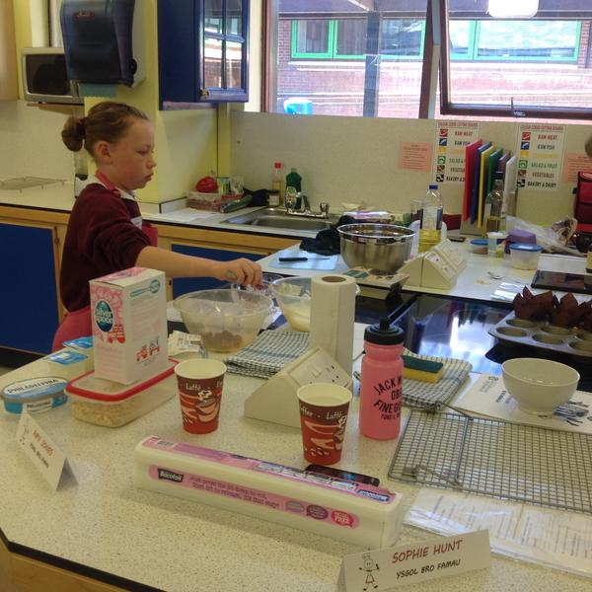
Dangosodd egin-gogyddion ifanc o Ysgolion Cynradd, Uwchradd ac Arbennig y Sir y gallent sefyll gwres y gegin, a medru cynhyrchu digon o safon uchel o goginio i greu argraff ffafriol ar ddau o gogyddion gorau'r DU yn Rowndiau Terfynol Fawreddog Bwydlen Fawr Sir Ddinbych 2015, a drefnwyd gan Gwasanaethau Addysg Sir Ddinbych.

Drwy ymateb i'r her o goginio prydau iar y thema 'Patagonia 150' (marcio 150 mlynedd ers yr ymfudo gan ymsefydlwyr Cymreig ym 1865), mae disgyblion o ysgolion Cynradd, Uwchradd ac Arbennig o bob rhan o Sir Ddinbych wedi dyfeisio syniadau gwreiddiol a blasus. ‘Roedd safon uchel ymdrechion y plant yn sicr o greu argraff ar y beirniaid, gan gynnwys y cogydd enwog Graham Tinsley MBE, sylfaenydd ac aelod o Dîm Coginio Cenedlaethol Cymru, Bryan Webb, cogydd safon serenog Michelin a pherchennog bwyty enwog Tyddyn Llan, Llandrillo, ger Corwen ac Andrew Davies, perchennog Morgan Pori Gwych, Cigyddion a Delicatessen, Caerwys. Hefyd, yn cynorthwyo gyda'r beirniadu oedd y Cynghorydd Ann Davies o Rhuddlan, Is-gadeirydd Cyngor Sir Ddinbych.
Bwydlen Fawr Sir Ddinbych 2015
Enillydd Ysgolion Cynradd
Amy Jones, Ysgol Bro Famau

Cynhaliwyd y Rowndiau Terfynol dros ddau ddiwrnod yn Ysgol Uwchradd Dinbych ac Ysgol Tir Morfa, Y Rhyl gyda phob enillydd o bob categori yn cael tlws a gwobr ar gyfer eu hysgolion. Cyfranodd nifer o fusnesau lleol a chenedlaethol, gan gynnwys Ravenscroft & Thackeray, Bwydydd o Safon, Dinbych , a Gwasanaethau Bwyd Blakemore, Gorllewin Canolbarth Lloegr, at lwyddiant y digwyddiad drwy noddi'r gwobrau. I ychwanegu at y wefr, mae'r cogyddion buddugol hefyd wedi cael eu gwahodd i gynorthwyo Graham Tinsley mewn arddangosiad coginio arbennig yng Ngŵyl Fwyd Llangollen ym Hydref 2015.

Dywedodd llefarydd ar ran Gwasanaethau Addysg Sir Ddinbych fod Bwydlen Fawr Sir Ddinbych 2015 – y cyntaf erioed, wedi bod yn uchelgeisiol, yn hwyl ac yn bleser mawr i gystadlu ynddo yn y gobaith o ysbrydoli plant Sir Ddinbych gyda’r potensial i fynd ati gydag angerdd a brwdfrydedd i goginio. Llongyfarchiadau i'r holl gogyddion ifanc a gymerodd ran eleni. ‘Rydym yn edrych ymlaen at y gystadleuaeth y flwyddyn nesaf.
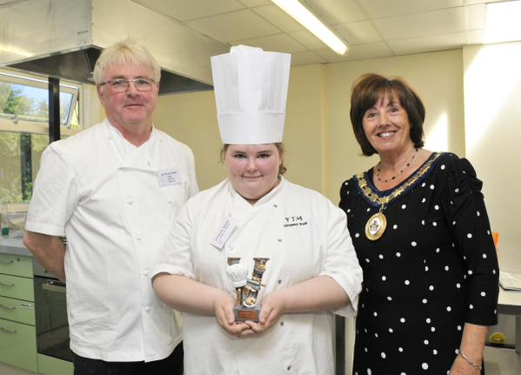
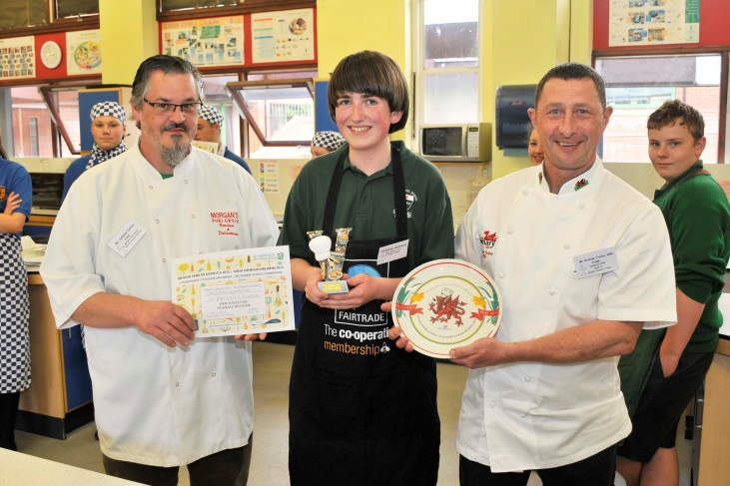

Bwydle

Bwydlen Fawr Sir Ddinbych 2015 Enillydd Ysgolion Arbennig
Victoria Smith, Ysgol Tir Morfa

Llun o Victoria Smith gyda beirniaid Bryan Webb a
Cynghorydd Ann Davies o Rhuddlan, Is-gadeirydd Cyngor Sir Ddinbych
Bwydlen Fawr Sir Ddinbych 2015 Enillydd Ysgolion Uwchradd
CAMERON ACKROYD, YSGOL SANTES FFRAID

Llun o Cameron Ackroyd gyda beirniaid
Graham Tinsley MBE ac Andrew Davies

PRESS RELEASE

THE GREAT DENBIGHSHIRE MENU 2015

‘PLEASE SIR, CAN WE HAVE SOME MORE’??…

Budding young chefs from Denbighshire Primary, Secondary and Special Schools showed they could stand the heat in the kitchen and could generate plenty of red hot culinary competition to impress two of the UK’s top chefs in the Grand Finals of the Great Denbighshire Menu 2015, organised by Denbighshire Education Services.

Rising to the challenge of cooking dishes to the theme of ‘Patagonia 150’ (marking the 150th anniversary of the emigration by Welsh settlers in 1865), pupils from Primary, Secondary and Special schools from across Denbighshire served some original and tasty ideas.
The high standard of the children’s efforts certainly impressed the judges, who included celebrity chef Graham Tinsley MBE, founder Member of the Welsh National Culinary Team, Bryan Webb, Michelin Starred chef and owner of the renowned restaurant Tyddyn Llan, in Llandrillo, near Corwen and Andrew Davies, award winning owner of Morgan’s Pori Gwych, Butchers and Delicatessen of Caerwys. Also helping out with the judging was Councillor Anne Davies of Rhuddlan, Vice-Chair of Denbighshire County Council.
Great Denbighshire Menu 2015
Primary School Winner
Amy Jones, Ysgol Bro Famau

The Finals were held over two days at Denbigh High School and Ysgol Tir Morfa, Rhyl and the winners of each category were awarded trophies and prizes for their schools. Many local and national businesses, including Denbigh based Ravenscroft & Thackeray Fine Foods and Blakemore Foodservice, West Midlands, contributed to the successful event by sponsoring the prizes. As an added thrill, the winning chefs have also been invited to assist Graham Tinsley in a cooking demonstration at the Llangollen Food Festival in October 2015.

Great Denbighshire Menu 2015 Special School Winner
Victoria Smith, Ysgol Tir Morfa

Victoria Smith pictured with judges, Bryan Webb and
Councillor Ann Davies, Vice Chair of Denbighshire County Council

Great Denbighshire Menu 2015 Secondary School Winner
CAMERON ACKROYD, ST BRIGID’S SCHOOL

Cameron Ackroyd pictured with judges,
Graham Tinsley MBE and Andrew Davies

A spokesperson from Denbighshire Education Services commented that the first ever Great Denbighshire Menu 2015 had been an aspirational, fun and enjoyable cooking competition which it hoped would inspire children in Denbighshire with real passion, enthusiasm and potential to get cooking. Congratulations to all the young chefs who took part this year. We look forward to next year’s competition.

