‘Dathlu Darllen Efo’n Gilydd!’ / ‘Celebrating Reading Together!’
Darllenwyr yn cyd-gyfarfod i ddathlu darllen / Readers come together to celebrate reading
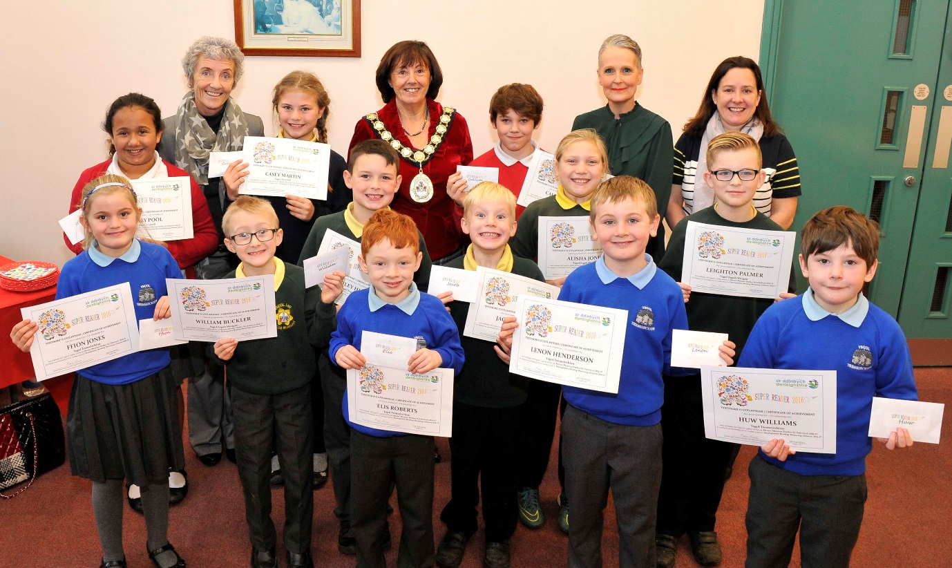

"’Dwi’n caru darllen yn fawr iawn ‘rwan, mae’r Dork Diaries yn gwneud i mi eisiau bod yn awdur ryw ddiwrnod"
“I really love reading now, Dork Diaries makes me want to be an author one day”

Disgybl Bl 6 / Y6 Pupil

Dydd Llun 5 mis Rhagfyr 2016, croesawodd y Cynghorydd Ann Davies, Cadeirydd, Cyngor Sir Ddinbych, plant a'u mentoriaid darllen o ysgolion ar draws y sir i Neuadd y Dref, Rhuthun i ddathlu eu llwyddiannau darllen dros y misoedd diwethaf. ’Roedd pob un wedi bod yn cymryd rhan ym Menter Mentora Darllen Sir Ddinbych drwy gydol tymor yr Hydref 2016.  Bellach yn ei drydedd flwyddyn lwyddiannus, mae Menter Mentora Darllen Sir Ddinbych yn croesawu gwirfoddolwyr o bob cefndir i helpu disgyblion mewn ysgolion i wella eu sgiliau darllen drwy dreulio rhywfaint o amser gyda hwy yn wythnosol, er mwyn eu hannog i ymarfer eu sgiliau darllen a darganfod yr hud o ddarllen mewn ffordd hwyliog, creadigol ac ysbrydoledig. Hyd yma, mae tair ar hugain o ysgolion Sir Ddinbych a 106 o blant wedi cymryd rhan yn y cynllun gyda chefnogaeth gan fentoriaid darllen gwirfoddol.  Mae dod yn fentor darllen yn ffordd wych i wneud gwahaniaeth parhaol i fywyd plentyn a mwynhau profiad gwirfoddoli hynod werth chweil.  "Gallwch roi'r hwb mwyaf hudol i hunan-barch plentyn drwy dim ond gwirfoddoli fel mentor ddarllen" meddai un o wirfoddolwyr Sir Ddinbych.  Drwy gydol Tymor yr Hydref 2016, mae tîm o 8 o wirfoddolwyr brwdfrydig wedi bod yn mentora disgyblion ysgolion cynradd trwy ddarllen gyda hwy a meithrin eu hoffter o lyfrau ac awduron. Drwy roi o'u hamser i’r fenter gwirfoddoli cyffrous hwn, bydd y mentoriaid yn ysbrydoli darllenwyr ifanc i gyrraedd eu potensial a dod yn fwy hyderus a brwdfrydig drwy ddarganfod byd hudol a lledrith geiriau llenyddiaeth plant.  Fel Cadeirydd Cyngor Sir Ddinbych, dywedodd y Cynghorydd Ann Davies ei bod yn falch iawn o fedru cynnal y digwyddiad a thalodd deyrnged i'r mentoriaid gwirfoddol a llongyfarchwyd y plant wrth iddi eu cyflwyno gyda thystysgrifau cyflawniad a llyfr thocynnau.  Mynegodd y Pennaeth Addysg a Gwasanaethau Plant ei diolch i'r mentoriaid, i’r ysgolion ac i’r plant am gymryd rhan yn y bartneriaeth hynod lwyddiannus hwn drwy hefyd edrych ymlaen ym 2017 i recriwtio mwy o wirfoddolwyr i ysgolion Sir Ddinbych.  Am fwy o fanylion ar sut i ddod yn fentor darllen, cysylltwch ag Adran Addysg a Gwasanaethau Plant Sir Ddinbych ar 01824 708064. | On Monday 5 December 2016, Councillor Ann Davies, Chair, Denbighshire County Council, welcomed children and their reading mentors from schools across the county to Ruthin Town Hall to celebrate their reading achievements over the past couple of months. All had been taking part in Denbighshire’s Reading Mentoring Initiative throughout the Autumn term 2016.  Now in its third successful year, Denbighshire Reading Mentoring Initiative welcomes volunteers from all walks of life to help pupils in schools improve their reading skills by spending some time with them on a weekly basis, to encourage them to practise their reading skills and discover the magic of reading in a fun, creative and inspiring way. To date, twenty-three Denbighshire schools have participated in the scheme and 106 children have been supported by volunteer reading mentors.  Becoming a reading mentor is a great way to make a lasting difference to a child’s life and enjoy a highly rewarding volunteering experience.  “You can give the most magical boost to a child’s self-esteem by just volunteering as a reading mentor” said one of the Denbighshire volunteers.  Throughout the Autumn Term 2016, a team of 8 enthusiastic volunteers has been mentoring primary school pupils by reading with them and fostering their love of books and authors. By giving of their time to this exciting volunteer initiative, the mentors will inspire young readers to reach their potential and become more confident and enthusiastic by discovering the magical world of words in children’s literature.  As Chair of Denbighshire County Council, Councillor Ann Davies said that she was delighted to host the event and paid tribute to the volunteer mentors and congratulated the children as she presented them with certificates of achievement and book tokens.  The Head of Education and Children’s Services expressed her gratitude to the mentors, the schools and the children for their participation in this highly successful partnership and looks forward in 2017 to recruiting more volunteers in Denbighshire schools.  For more details about becoming a reading mentor, contact Denbighshire Education and Children’s Services on 01824 708064.

